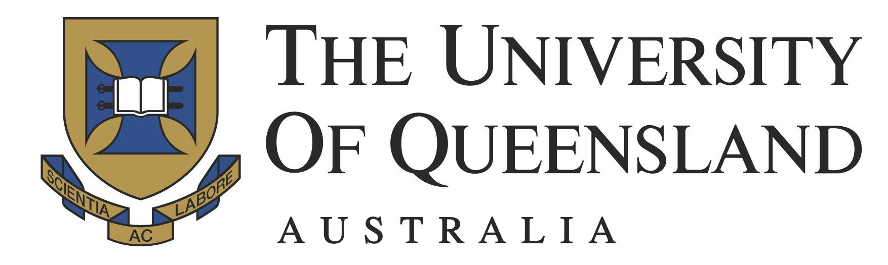

MASTER of MENTAL HEALTH - ART THERAPY

INFORMATION BOOKLET – Full Time Option for International Students

For Intake in March 2018

International Students

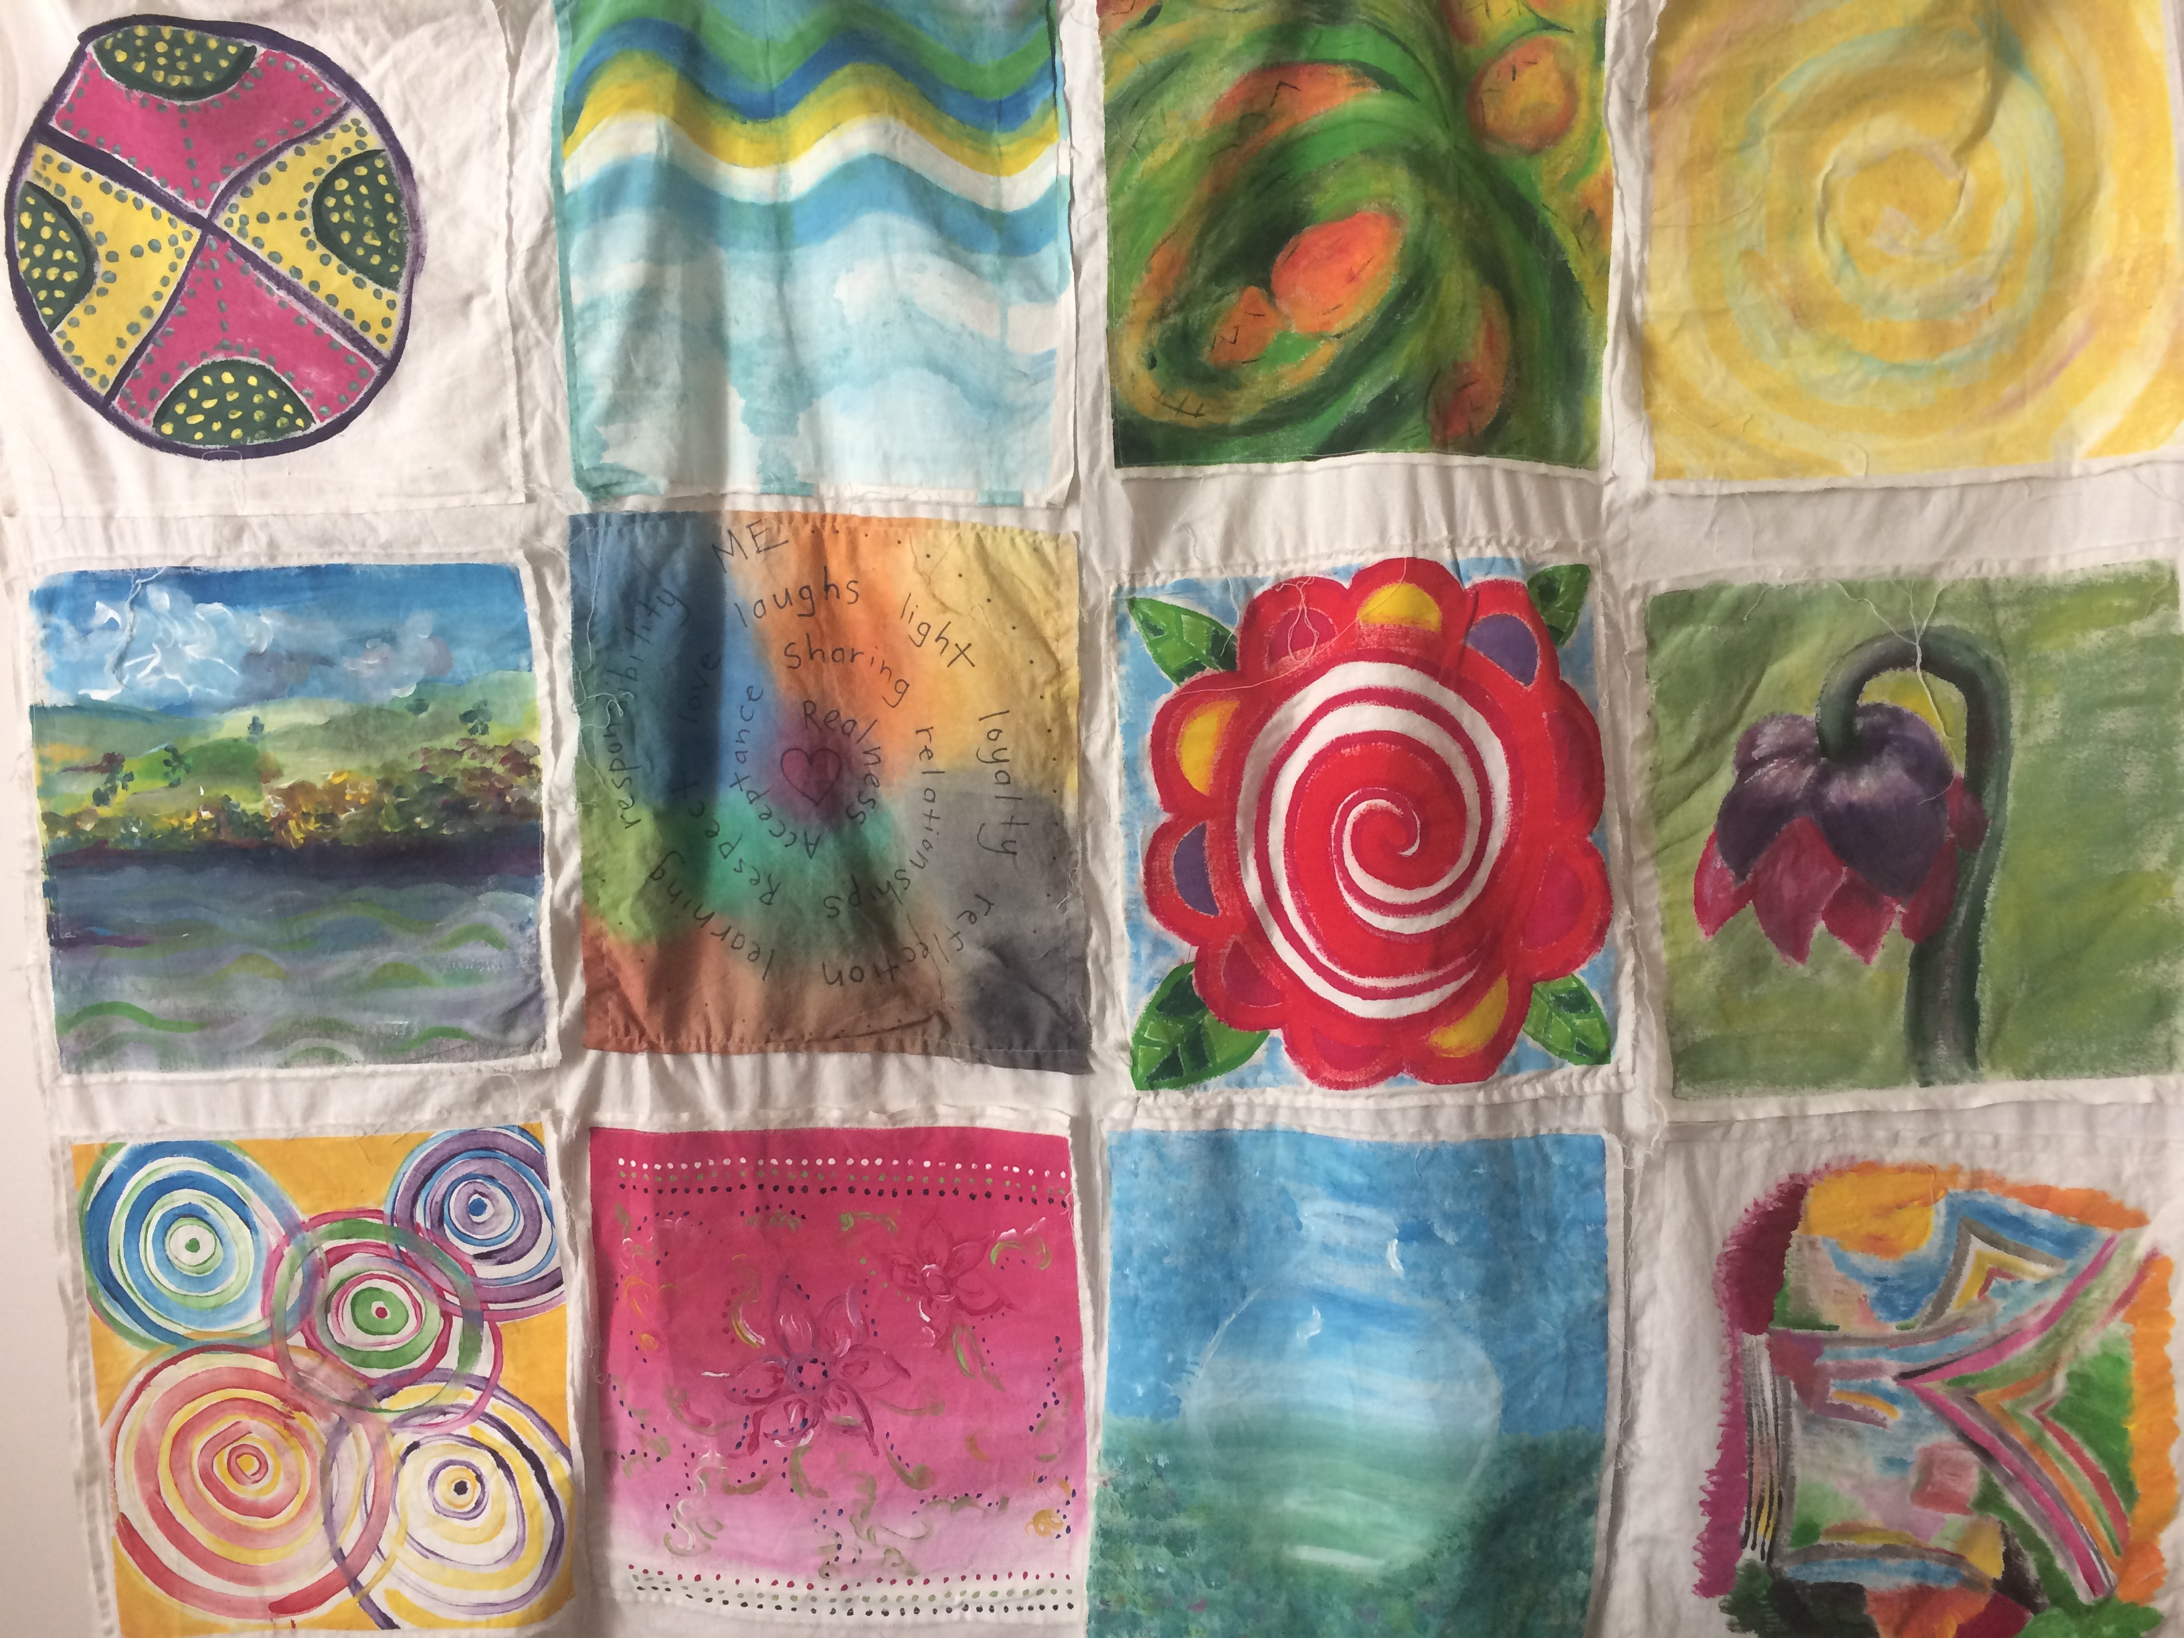

Art work by art therapy students March 2013

Faculty of Medicine
The University of Queensland
Australia
Thank you for considering the Master in Mental Health - Art Therapy at the University of Queensland.

Our program meets the professional registration of the Australian and New Zealand Art Therapist Association Inc. (ANZATA). We believe our course has many unique qualities and our mission is to help you have the optimum learning experience. Each student is treated as an individual and this is easily maintained with small classes and qualified staff with various specialities and interest areas. Our staffs are all experienced practitioners who also have teaching experience.
Our teaching team have graduated from internationally recognized programs in the UK, USA, Canada and Australia and our program captures the best of these training programs.
Just over ten years old our program has also become popular in Australia and overseas, with graduates from USA, United Kingdom, New Zealand, Taiwan, Singapore, Hong Kong and Korea. Our program structure is such that our students are on placement for the entire program, and we assist students in finding the placement sites that will support and extend their learning. The course is a full time option for overseas students to fit in with their visa requirements.

Please read through this booklet then feel free to contact:

International Admissions
UQ International
University of Queensland
Email: E: applicationstatus@uq.edu.au W: future-students.uq.edu.au
T: +61 7 3365 7941

Or

Jane O’Sullivan
Field Coordinator
Dip T; B.Ed: M.A (Expressive Therapies) USA; AthR
Master of Mental Health - Art Therapy UQ
Email: jane.osullivan@uq.edu.au

regarding individual queries.

Introduction

Master of Mental Health – Art Therapy

The Master of Mental Health – Art Therapy has been developed to train people in the therapeutic use of art and art practice. It is part of a suite of Psychotherapy programs based in the Faculty of Medicine, University of Queensland. The program has high expectations and standards, all courses are taught by senior academics, researchers and clinicians.

The MMH-Art Therapy is designed to produce professional art therapists with high ethical standards and with confidence to engage in art therapy practice at a professional level.

Art Therapy

Art therapy is a process or method of working with individuals and groups in order to maximise mental health, using a combination of art activities and verbal interaction. Art therapy is not just a collection of techniques, but is a planned intervention which attempts to create a safe environment for clients to express him or herself using art. Art therapy draws on psychodynamic theory, Jungian analytical psychology, developmental theory, and humanistic psychotherapies for its theoretical framework. It incorporates concepts about creativity as well as a range of therapeutic approaches and methods.

ANZATA and registration

The Australian and New Zealand Arts Therapy Association Inc., ANZATA, (formerly ANATA) is a non-profit organisation founded in 1987. Professional members are Art Therapists who have completed recognised postgraduate training that meets professional standards. ANZATA provides information on research, employment, education and publications. ANZATA is actively working on establishing standards for Art Therapy training, registration and clinical practice. Art Therapists involved in the development of the MMH-Art Therapy are active and leading members of ANZATA. In 2004 Brisbane hosted the National Conference of ANZATA.

Graduates of the MMH-Art Therapy will be eligible to apply for Professional membership of ANZATA and to become Registered Art Therapists.

Personal Therapy
ANZATA strongly recommends that all art therapy students have some experience of personal therapy, either prior to or during their MMH – AT training. This is to enable them to become more aware of their personal motivation for becoming a therapist, and to identify any potential areas of difficulty.

Master of Mental Health – Art Therapy

Program Structure

International students complete the program full time in three semesters. The program has recently undergone a significant restructure. The basic components of the program (art therapy theory, experiential art therapy workshops, clinical art therapy placements and mental health units) have not changed. Mental Health units include art therapy content. Students will be expected to be on placement throughout each of the three semesters and to complete 800 hours of clinical practice in total.

Semester 1 2018  PXMH7023  Foundation Knowledge for Mental Health Practice | Semester 2 2018  PXMH7028  Core Knowledge for Mental Health Practice | Semester 1 2019  PXMH7035  Art Therapy in Clinical Practice
PXMH7024  Foundation Skills  for Mental Health Practice | PXMH7029  Core Skills for Mental Health Practice | PXMH7036  Art Therapy with Special Populations
PXMH7025  Application of Foundation Skills in Mental Health Practice  (200 hours prac.) | PXMH7030  Application of Core Skills for Mental Health Practice  (200 hours prac.) | PXMH7037  Application of Specialist Art Therapy Skills in Mental Health Practice A  (200 hours prac.)
PXMH7067  Independent Mental Health Project A | PXMH7038  Application of Specialist Art Therapy Skills in Mental Health Practice B  200 hours prac (these additional hours can be spread across the three semesters) | PXMH7068  Independent Mental Health Project B

Placement Requirements

Consistent with ANZATA and PACFA standards, candidates are required to complete at least 800 hours of art therapy placement over the course of the program. Students will need to do some forward planning with the placement coordinator to manage this part of the program.

Times and Locations of Classes

Weekly placement supervision, seminars and classes will generally be held in the afternoons, or evenings from 5.00pm, up to twice a week. These may be on Tuesday, Wednesday and/or Thursday evenings depending on the course and the semester. There will also be a number of one-day workshops, usually in blocks of two days or more, which are usually but not always on weekdays and/or Saturdays during semester. All times and locations will be in the Electronic Course Profiles on the UQ website which can be accessed once you have enrolled.

Seminars and workshops in the Art Therapy courses for 2017 will generally be held in:
The Health Sciences Building, Herston Campus or K Floor Mental Health Centre, RBWH, Herston, Brisbane

Staff

The following academic staff are lecturers and/or tutors on the MMH - Art Therapy program. All teaching staff are either senior Art Therapy or Psychotherapy practitioners.

Matthew Bambling is the overall Program Director for the Master of Mental Health, Faculty of Medicine UQ. He is a clinical psychologist with extensive experience in the provision of mental health services to adults, families and children. His research interests are psychotherapy outcomes, the supervision of therapists and mental health.

Lauren Johnson qualified as an Art Psychotherapist at Goldsmiths College London in 2011. Lauren is also trained in Sandplay Therapy and Symbol Work, and is a level 1 Theraplay facilitator. Lauren is registered with the Australian and New Zealand Arts Therapy Association (ANZATA), The British Association of Art Therapists (BAAT), and the UK Health and Care Professions Council (HCPC).
Lauren has been employed as an Expressive Therapist at yourtown’s domestic and family violence refuge for the past 5 years. She provides individual and family expressive therapy to children aged 0-15, and therapist-parent psycho-education and psychotherapy. Lauren specialises in early intervention with children aged 0-5, running a child-parent expressive therapy program designed to support attachment repair between children and their parents. Lauren has previous experience working in forensic mental health and a primary school setting.
Claire Edwards qualified as an art therapist at Goldsmiths College, University of London (1984). She has a research Masters (Hons) in Art Therapy from UWS (2005) and a Masters of Social Work (2013). She has extensive experience working in child, youth and adult mental health, alcohol and drug rehabilitation, and community based children’s counselling services. Claire works in private practice at Kooky Kid Clinic in Springwood, as well as offering professional supervision and facilitating training workshops.

Louise Leotta graduated from Concordia University in Montréal with a Masters degree in the Creative Arts Therapies (2008). In Canada, Louise gained experience working in a psychiatry team at the Montréal Children’s Hospital and at a centre for adults with developmental disabilities. In Australia, Louise co-ordinated a therapy program supporting children and their families after parental separation. Louise is an accredited drumbeat facilitator, has lectured drama and art therapy postgraduate and professional development courses at a holistic counselling college and has experience in group therapy, trauma, child safety and professional supervision. Currently, Louise works as an Art therapist on the Child and Youth Mental Health Inpatient Unit at the Lady Cilento Children’s Hospital and at Silky Oaks Children’s Haven on the Child and Family Therapy Team.

Tom O’Brien is a Senior Lecturer in the Faculty of Medicine, University of Queensland. He is a Clinical Social Worker and psychoanalytic therapist. Tom currently works for the Child and Youth Mental Health Service, Childrens’ Health Queensland, Hospital and Health Service.

Jane O’Sullivan graduated from Lesley University in Boston USA as an Expressive Therapist in 1991. Jane is an Australian registered art therapist and Life member of the National Expressive Therapies Association (USA). Jane worked at the Mater Children’s Hospital Child and Youth Mental Health Service for 13 years as an art therapist working with young people and their families. Jane has also worked as an art therapist in private practice delivering art therapy group programs to different client populations including adult oncology, parents living with mental illness, children from refugee backgrounds and facilitating group supervision. Jane is the Field Coordinator for the Masters of Mental Health – Art Therapy.

Natasha Palethorpe is an art therapist who completed her training in Australia. She obtained a Grad Dip in Expressive Therapies at UWS and obtained her Masters in Art therapy from ECU. She has previous experience working within the disability, justice, child protection, drug and alcohol, torture and trauma survivors and with refugee youth and their families. Natasha has a Master of Occupational Therapy in response to being able to support client’s emotional and physical needs. Natasha now works as a regional health advisor for a mining company focusing on holistic physical and mental health, utilising creative approaches to target and improve health and well being of all employees.

Maggie Wilson worked initially as a high school art teacher. She trained at Goldsmiths College London University in Art Psychotherapy in 1990. Since graduating MAggie has been a Professional member of ANZATA for 27 years and is an Australian Registered Art Therapist. Recently Maggie completed a Certificate in Clay Field Art Therapy, from the institute for Sensormotor Art Therapy.
Maggie has worked as an art therapist in drug and alcohol treatment, homelessness, and child and youth mental health. She worked for 14 years as a CYMH art therapist and as the COPMI (Children of Parents with a Mental Illness) Program Co-ordinator for CHQ HHS Child and Youth Mental Health (CYMHS) Queensland Health.
Maggie has just completed a sabbatical in Northern Italy participating in volunteer art therapy with young African refugees in northern Italy.
She has conducted a private practice ‘The Art Therapy Studio’ in Northern NSW Australia for over 27 years. Her private practice interests are art therapy supervision both individual and group work, are cross-cultural Art Therapy group work, creative debriefing and supervision for mental health teams and practitioners. She also does see individual clients for Art Therapy and Clay Field Sessions.
MMH – Art Therapy Entrance Requirements

Please read this section carefully. It explains the prerequisites and application process, which is somewhat complex. We are continually updating this process to enable applicants to understand whether they meet these prerequisites, or if further preparatory training or work experience is necessary.

To enrol in the Masters of Mental Health – Art Therapy, applicants need to satisfy entrance standards in all of the following three areas: Academic Capacity, Art Practice, and Clinical Experience, and if eligible, to undertake an art making group experiential as the next step towards acceptance into the program. Potential applicants will be notified one week after attending the group art-making experiential session if they have been accepted in the program.

1. Academic Capacity
To be offered a place in the Master of Mental Health - Art Therapy, an applicant must possess an undergraduate degree.
- Applicants who possess an undergraduate degree which is not in a relevant or approved area of study ¹ will need permission to enrol in the Master of Mental Health.

¹ Note: Either a visual art degree or a social welfare/mental health degree such as social work, psychology, nursing or Occupational Therapy is considered to be a relevant degree.

2. Art Practice
The art practice requirement can be met by the following means:
- Possession of a recognised Visual Arts Degree, plus evidence of demonstrated ongoing commitment to art practice in any medium or
- A recent portfolio of artwork which has been completed with or without formal art training but which demonstrates a commitment to continuing art practice in any medium
Either a visual art degree or a social welfare/mental health degree such as social work, psychology, nursing or Occupational Therapy is considered to be a relevant degree.

Art Portfolio and Written Art Statement
The Portfolio should be a selection of six to ten recent (completed within the last 2 years) images and/or artworks created by the applicant over a period of time. This can consist of original work or reproductions (i.e. photographs or slide show) in a variety of media. The purpose of the Portfolio is to provide the selection team with evidence of the applicant’s ongoing art activity, which is a prerequisite of professional art therapy training. Your portfolio should include;
A maximum of ten pieces of artwork, which may be presented through:
- Original work
- Photos
- Video
- PowerPoint
The portfolio can also include:
- A description of an exhibition
- Examples of media exposure
- Community art projects
Brisbane Institute of Art, TAFE and other training institutions provide art courses which may assist in the process of preparing the Portfolio.

Written Art Statement
The art statement is a written statement of a minimum of 1000 words which will:
1. Demonstrate how your art making equips you for study of art therapy
2. Demonstrate your ability to discuss your art making process and personal impact explaining how you use art as a reflective tool. You will select three pieces from your submitted portfolio to discuss.

Below is the criteria the art component needs to meet:
Artistic statement
Demonstrates skills of art making used in the last two years with 6 - 10 pieces

Demonstrates knowledge about using art as a reflective tool in the written artistic statement and can state examples
Demonstrates appropriate awareness of personal process of using art as a reflective tool by being able to discuss three selected pieces of the art portfolio
Demonstrates appropriate skills of using different art media
Demonstrates an understanding of the skills needed to be an art therapist by discussing their reasons to pursue the program

3. Clinical experience and written professional statement
The following guidelines will help you determine whether you meet the relevant (clinical) experience requirement. The rules of entry require that all applicants possess a degree in a mental health, social welfare or related area, or have completed an approved counselling skills program. These requirements can be met by one or more of the following:

- Possession of a relevant recognised degree (i.e. nursing, social work, social welfare, psychology, occupational therapy, medicine or a related field), plus 2 years of mental health or related practice;

2. Completion of counselling course approved by the Executive Dean, plus 2 years of mental health or related practice in the welfare field. A counselling program would need to provide both theory training and certified competence in core microskills and counselling ethics.

Written Professional Statement.
The professional statement will be a written statement of a minimum of 1000 words describing:
- how your training and experience meet the entry requirements for the program
- an interaction you have had with a client that demonstrates your understanding of a counselling scenario in either paid or voluntary work .
Below are the criteria the professional and clinical experience needs to meet:

Professional statement
Demonstrates skills working with people with mental health issues and contains information about their professional experience
Demonstrates knowledge about mental health issues and the clinical aspects of mental health issues
Demonstrates appropriate awareness of professional issues and contains information about professional practice values or framework
Demonstrates appropriate awareness of ethical issues such as ethical considerations
In the written case example is able to demonstrate most of the above skills by detailing a description of an interaction with a client (voluntary or paid work )

Experience in Mental Health or Related Practice

All applicants, with or without professional degrees, must be able to identify at least two years’ experience of mental health or related practice. In your initial written application, you must be able to demonstrate that you have met all these requirements. In considering your experience with mental health or related practice, it is suggested that you bear in mind the following:

- Teaching is not generally considered to be equivalent to mental health experience, unless it substantially involves a pastoral role, is and substantially in special education, or another specialised role with responsibility for student welfare or behaviour management.
- Experience does not have to be in specialist mental health settings: work in areas where exposure to people with mental health problems is significant, such as: general health settings, special education, youth work, substance use treatment settings and broader social welfare settings can be considered.
- Experience does not have to be in paid employment – voluntary work, personal experience with mental illness, care of family members and friends can also be taken into account.

Experience does not have to be continuous or full time, but it should include work periods of six months or more in the same agency or role.

Blue Card
Students will need a ‘working with children’ blue card to be able to access placements with children or young people in Queensland. In order to facilitate placement processes, it is the student’s responsibility to ensure they have a valid blue card prior to enrolment in the program. If there is any reason why you may not be eligible to apply for a blue card you must discuss this with the Student Administration, Faculty of Medicine and Field Co-ordinator prior to enrolment:

Student Administration
Faculty of Medicine
Email: med.enquiries@uq.edu.au
Phone: (07) 336 55142

Or

Jane O’Sullivan
Field Coordinator
Email: jane.osullivan@uq.edu.au

The Blue Card application form can be accessed from this link. There is no charge for student applications. Please forward a copy of your Blue Card notice or Blue Card link to Student Administration, Faculty of Medicine for your student record.

Fees

Please refer to the UQ website for current fee information. Fees are payable on a semester by semester basis.

Scholarships
You can find out information on scholarships and financial assistance here.

Application Process

International applicants should apply through International Admissions at the following; http://www.uq.edu.au/international-students/application-instructions.

The program code is 5151 and plan code for Art Therapy is ARTTHX5151.

You should attach all relevant qualifications and official academic transcripts including your current resume or curriculum vitae.

Interview

All candidates will undergo an interview to assess their suitability and qualifications both in human service delivery and art practice. This will be organized at a time to suit you, in your time zone, via phone and/or Skype. This will be an individual interview (about 30 to 60 minutes) to discuss your application, in particular: your experience of clinical practice; your art practice; and why it is important to you.

Fees & International Information

For future international students enquiring about application status: Email: applicationstatus@uq.edu.au, information for International applications can also be found at www.uq.edu.au/international-students/contact or at:

UQ International
Level 2, JD Story Building (Building 61)
St Lucia Campus
The University of Queensland
Brisbane Queensland 4072
Australia

2018 Intake: It is highly recommended that international students apply as soon as possible in the year prior to intended entry

July - November 2017 Phone Interviews
Late February/early March 2018 Classes begin
Application Checklist

What |  | Check √
Upload completed online application which will include;
- Current resume or CV
- Certified copies of academic transcripts and award certificate
- Art portfolio
- Written professional statement
- Written artistic statement
Blue Card Application | January 2018

For further program information:

Jane O’Sullivan
Field Coordinator,
Masters of Mental Health – Art Therapy
The University of Queensland
Email: jane.osullivan@uq.edu.au

